IEEE P802.11
Wireless LANs
Responses to Functional Requirements and Comparison Criteria for Texas Instruments Proposal for IEEE 802.11g High-Rate Standard
November 4, 2000
Sean Coffey, Chris Heegard, and Matthew Shoemake
Texas Instruments
141 Stony Circle, Santa Rosa, CA 94116
Phone: +1 (707) 521 3060
Fax: +1 (707) 521 3066
e-Mail: coffey@ti.com
, (Texas Instruments)
Abstract

The following are the responses to the Functional Requirements and Comparison Criteria for our proposal to IEEE 802.11g.

General Requirements

- The proposal must be an extension of the IEEE 802.11b standard.
The proposal is an extension of the IEEE 802.11b standard. The proposal adopts IEEE 802.11b packets formats at 1, 2, 5.5 and 11 Mbps using Barker, CCK and PBCC formats. The proposal adopts the long preamble of the IEEE 802.11b standard and requires supporting the short preamble of the IEEE 802.11b standard.
The proposal is an extension of the IEEE 802.11b standard in the sense that it adds a new modulation at 22 Mbps. This modulation uses the same hooks that were placed in the IEEE 802.11b standard to allow CCK and PBCC to operate seamlessly with legacy IEEE 802.11-1997 compliant systems. These same hooks allow for seamless extension of IEEE 802.11b to 22 Mbps in a backward compatible and coexistent fashion with the IEEE 802.11b standard.
- The proposal shall specify a PHY that implements all mandatory portions of the IEEE 802.11b PHY standard
The proposal includes all mandatory portions of the IEEE 802.11b PHY standard, including but not limited to long preamble, Barker modulation and CCK modulation.
- Must comply with IEEE 802 patent policy

Texas Instruments supports the IEEE patent policy and will fully comply with it.

- Backward compatibility with 802.11b
The proposal is fully backward compatible with the IEEE 802.11b system. An IEEE 802.11g system based on this proposal will be capable of full interoperability with a system that is compliant with the IEEE 802.11b system. This is achieved by transmitting packets using only the modes of the IEEE 802.11b standard, namely 1 or 2 Mbps Barker, 5.5 or 11 Mbps CCK, or 5.5 and 11 Mbps PBCC.
- All proposals must not render existing 802.11b compliant products non-conformant with the resulting, supplemented IEEE 802.11 2.4GHz standard.
This proposal does not, nor is it the intent of this proposal, to render existing 802.11b compliant device non-conformant with the new 802.11 2.4GHz standard. If this proposal is accepted as the TGg supplement to the IEEE 802.11 2.4GHz standard, devices that are 802.11b compliant will remain 802.11b compliant. IEEE 802.11b compliant and IEEE 802.11g compliant devices will fully interoperate, independent of the options that are implemented in the IEEE 802.11b compliant device.
- The proposal shall not repeal any options in the IEEE 802.11b standard.
This proposal does not repeal or disable any options of the IEEE 802.11b standard. In addition, this proposal includes as mandatory the short preamble option of the IEEE 802.11b standard and the 5.5 and 11 Mbps PBCC options of the IEEE 802.11b standard.

MAC Interface Requirements
- The proposal must be compatible with the IEEE 802.11 MAC standard. Clarification note: Compatibility with the IEEE 802.11 MAC may be achieved by changes to MIB variables.
This proposal fully embraces and is compatible with the IEEE 802.11 MAC. It is the intent of this proposal to allow operation with the IEEE 802.11-1997/9 MAC as well as the IEEE 802.11e and IEEE 802.11f supplements of the standard. As with CCK and PBCC, this proposal will require the definition of new valid patterns in the rate field. This proposal will also require the use of one additional reserved bit in the header to non-ambiguously represent the length of the MPDU in use when 22 Mbps mode is employed. Likewise, minor modifications to MIB variables will need to be named to define the 22 Mbps mode. These changes are exactly analogous to the changes that were required to add 5.5 and 11 Mbps CCK and PBCC to the 2.4GHz standard.

Performance Requirements
- The maximum PHY data rate of the proposal must be at least 20Mbps
The maximum PHY data rate of the proposal is 22 Mbps, which is in excess of 20 Mbps.

RF Requirements

- All proposals shall operate in the 2.4GHz band
The proposal operates exclusively in the 2.4GHz band; thus it is a valid extension to the IEEE 802.11 2.4GHz Wireless LAN Standard. The proposal uses the same spectral mask as used in IEEE 802.11b and requires no changes to the RF section with respect to IEEE 802.11b implementations.
- Channelization same as 802.11b, i.e. same 5MHz channel spacing and center frequencies
The proposal uses the same channelization scheme as used in the IEEE 802.11b standard. The center frequencies remain at exactly the same frequencies, and the spacing of channels does not change.

IEEE P802.11
Wireless LANs

Answers to Comparison Criteria for TI IEEE 802.11g Proposal

General

- Modulation Technique, e.g. QPSK, QAM, OFDM, etc.
The legacy modulation schemes from 802.11b are BPSK and QPSK. The proposal adds 8-PSK.

- Data rates
The 1, 2, 5.5, and 11 Mbps rates used in 802.11b are retained, and in addition a 22 Mbps rate is added.
- Reference submissions
00/91 “Higher Rate 802.11b: Double the Data Rate”, Matthew Shoemake, Chris Heegard, Sid Schrum (Alantro).
00/92 “Spread Spectrum and 802.11b”, Chris Heegard (Alantro).
00/285 “Modeling Multipath and Fading”, Chris Heegard (Texas Instruments).
00/xxx “Texas Intruments Proposal for IEEE 802.11g High-Rate Standard”, Chris Heegard, Eric Rossin, Matthew Shoemake, Sean Coffey, Anuj Batra (Texas Instruments).
00/xxx “Responses to Functional Requirements and Comparison Criteria for Texas Instruments Proposal for IEEE 802.11g High-Rate Standard”, Sean Coffey, Chris Heegard, Matthew Shoemake (Texas Instruments).
00/xxx “Options for Texas Instruments Proposal for IEEE 802.11g High-Rate Standard”, Anuj Batra, Chris Heegard, Eric Rossin, Matthew Shoemake (Texas Instruments).

MAC Related
- Required changes to interface to 802.11 MAC
The TI proposed 22 Mbps solution requires little change to the 802.11 MAC. Obviously, the MAC must be able to transmit, receive and process data at the higher rate of 22 Mbps. Only one change in the MAC service primitives is required. The Transmit procedure starts with the PHY_TXSTART.req(TXVECTOR) primitive. The TXVECTOR contains a DATARATE field. The range of this DATARATE field must be expanded to include an encoding for the 22 Mbps mode. This same modification must be made to the RXVECTOR in the PHY_RXSTART.ind service primitive. Note that this modification will have to be made for any high rate extension proposal.

Notes on changes to the PHY PLCP: (this is technically not part of the MAC)
- A new PHY SIGNAL field encoding must be chosen to represent this modulation mode. This is the embodiment of the "DATARATE" field of the abstract service primitives mentioned previously. This will be required for any high rate extension.
- A second Length Extension bit must be added to the SERVICE field to resolve the ambiguity over the number of bytes in the MPDU. This will be required for any high rate extension.

Interoperability and Coexistence
- Means of achieving backward compatibility and interoperability with 802.11b
Backward compatibility is achieved by retaining the packet formats at 1, 2, 5.5 and 11 Mbps using Barker, CCK and PBCC formats, using the same long preamble and the 802.11b optional short preamble. All these behave exactly in the proposed system as they do in 802.11b.
Interoperability is achieved by introducing the 22 Mbps mode via previously unassigned combinations in the SIGNAL and SERVICE fields in the PLCP header. As in addition the 802.11b PLCP header, including the LENGTH field, is retained, an 802.11b compliant device that receives a 22 Mbps signal behaves correctly in staying idle for the duration of the high rate transmission. Furthermore, this behavior and the resulting MAC-level actions ensure that a high rate device may negotiate an appropriate rate with an 802.11b device.

- Impact on options in 802.11b
It is proposed that the 5.5 and 11 Mbps PBCC schemes should become mandatory. It is proposed that it should be mandatory for an 802.11g device to support the short preamble currently present as an option in 802.11b. It is proposed that the frequency-hopping scheme of 802.11b should remain an option.
7. Level of coexistence with Bluetooth 1.0b (802.15.1) and other 802 standards in the 2.4GHz. (Response to this item is optional.)
The proposal achieves a combination of high rate with high levels of robustness. As such, for transmissions with fixed packet sizes the transmission time is relatively small, and thus the probability of colliding with a Bluetooth or other transmission is relatively small.

Channelization
- Spectral characteristics
The channelization used will be identical to the existing 11 Mbps 802.11b system. The frequency range of 2.412 GHz to 2.484 GHz will be divided into 14 overlapping channels of 30 MHz each. The center frequencies of the 14 channels are spaced 5 MHz apart. This channelization is flexible all over the globe and the specific channels used vary from country to country based on the rules set by the individual country's regulatory agency.

- Adjacent channel and co-channel interference rejection
Adjacent Channel Interference

The proposed 22 Mbps scheme involves symbol transmission at the rate of 11 Msps, which is the same as the rate used in the existing 802.11b scheme. The proposed scheme achieves the higher data rate by transmitting 2 bits per symbol rather than the 1 bit per symbol transmitted in the existing scheme. The symbol rate being the same, the bandwidth expansion factor available in the existing 802.11b scheme is readily available in the proposed scheme as well. The large bandwidth expansion factor enables use of an analog filter in the RF section that can highly attenuate adjacent channel frequencies. In fact, an analog filter may be easily designed that drops by 37 dB in less than 1 MHz and such a filter eliminates adjacent interferers for all practical purposes without affecting the spectrum of the transmitted signal.

Co-Channel Interference

The proposed scheme uses no chip sequences for bandwidth expansion. Rather, a robust coding scheme is used to provide the bandwidth expansion factor. This turns out to be particularly advantageous in minimizing the co-channel interference. Once a training sequence is sent, the channel is equalized to the proper transmitter. Co-channel interference from any other transmitter exhibits almost zero correlation with the intended signal due to their non-chip sequence nature and can be treated as additive noise.

Co-channel interference is further minimized by incorporating the scrambler pn sequence. This is a constant pn sequence that modulates the transmitted data and maps the transmitted codeword to a translate of itself. Thus it becomes extremely unlikely that data from an interfering trasmitter has any resemblance to a valid code word from the desired transmitter.

RF Characteristics
- Required carrier frequency accuracy in PPM
The proposed 22 Mbps mode requires the same carrier frequency accuracy as that of the 11 Mbps 802.11b scheme, that is, +/- 25 ppm.
- RF PA backoff from 1 dB compression point
See response to Item 17.

Complexity
- Equalizer complexity and performance impact. (Prefer but do not mandate description of receiver structure(s).)
The equalizer complexity required to implement the proposed 22 Mbps solution is equivalent to that of the 11 Mbps CCK and PBCC modes in the current standard. The only required additional hardware would be the ability to slice PSK decision regions and generate update errors, for example, on 8-PSK, not just QPSK. The performance impact is in turn also equivalent to that of the 11 Mbps CCK and PBCC modes.

- RF/IF complexity relative to current 802.11b PHYs
The RF/IF complexity is exactly the same as for current 802.11b PHYs.
- Baseband processing complexity relative to current 802.11b PHYs (gate counts, MIPS, etc.)
In addition to the complexity of implementing the current 802.11b, including the PBCC options, the 22 Mbps high performance mode requires decoding the rate 2/3, memory 8, convolutional code. This can be done in 19712 MIPS, that is, 896 operations per bit. The PBCC 11 Mbps option, with a rate ½, memory 6 code, has a decoding complexity of 2112 MIPS, that is, 192 operations per bit.
 | Adds / info. bit | Compares / info. bit | Multiplies / info. bit | Operations / info. bit
11 Mbps CCK | 36 | 8 | 8 | 56
11 Mbps PBCC | 132 | 64 | 0 | 196
22 Mbps PBCC | 1028 | 768 | 0 | 1796

Performance
Additive White Gaussian Noise Interference

- AWGN PER performance at packet lengths of 100B, 1000B and 2346B

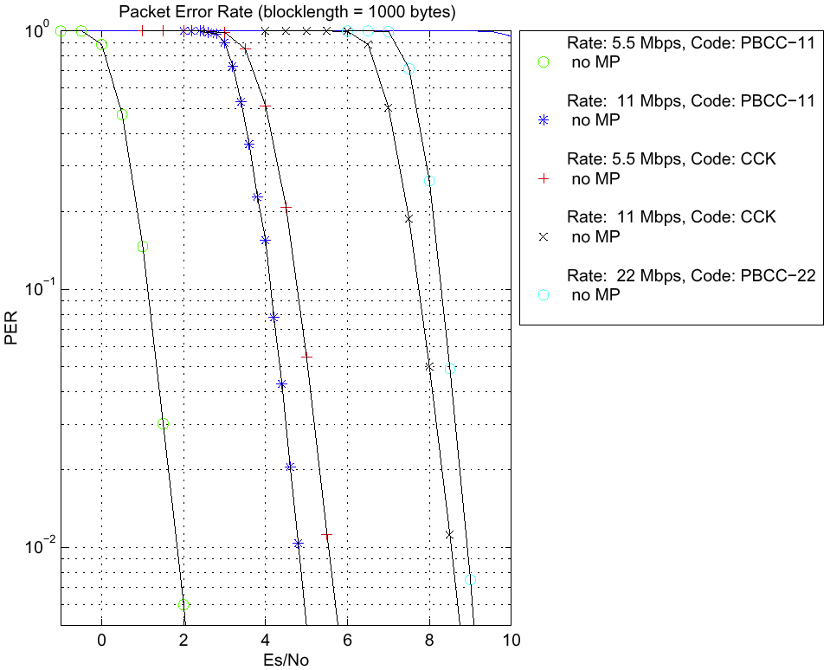
- CCA mechanism description
The proposed solution performs CCA according to a combination of two of the methods listed in 802.11b, with modification as listed below.
The first method is that CCA reports a busy medium upon detecting any energy above the ED threshold, as in 802.11b CCA Mode 1.
In the second method, the received signal is continually correlated with the Barker sequence; the resulting signal is processed to decide whether busy medium is reported. If the incoming PLCP header passes CRC, a timer of length equal to the LENGTH field in the header is started. CCA reports an idle medium after the timer expires and the correlator output drops below threshold. This mechanism is basically that of 802.11b CCA Mode 5, except that CCA Mode 5 indicates busy “at least” while a High Rate PPDU with energy above threshold is being received.
It is proposed that the MAC be configured to wait at least the maximum PSDU length of a non-Barker mode (3.65 ms) upon waking before relying on the CCA signal. This is essentially CCA Mode 4 from 802.11b.
Non-Ideal Power Amplifier Effects
- Simulate PER performance versus AWGN with packet lengths of 1000B with non-ideal power amplifier. Simulation should be run at oversample rate of 4x. Use RAPP power amplifier model as specified in document 00/294. Use P-parameters of 2 and 3. Specify backoff from full saturation used in the simulation calculated as
PA_{Backoff} = –10 log₁₀(Average TX Power/Power at saturation)
- Using the RAPP power amplifier model in doc. 00/294, show change in spectral characteristics due to non-ideal power amplifier as input power is swept over a reasonable range.
The proposed PBCC-22 mode uses exactly the same pulse shape as CCK and PBCC-11. The correlation in data introduced by the code has some influence on the spectrum; as the PBCC modes are non-block, this can be expected to result in, if anything, a slightly better spectrum than for CCK. The plots below indicate that this difference is negligible, however.

19. Describe the pulse shaping filter used at the input to the power amplifier in items 17 and 18. Show the resulting power spectrum at the input to the PA
A square root raised cosine filter with a rolloff factor of α = 0.7 is used.

Throughput and Overhead

- What are the possible preambles?

The proposal uses the 802.11b preambles, that is, the mandatory long preamble and the (802.11b-) optional short preamble. It is proposed that both preambles should be mandatory supported in 802.11g.

- Maximum data throughput at all combinations of:
  - Packet sizes of 100B, 1000, and 2346B
  - With and without acknowledges (ACKs)
  - All proposed preamble lengths (including 802.11b short and long preambles)
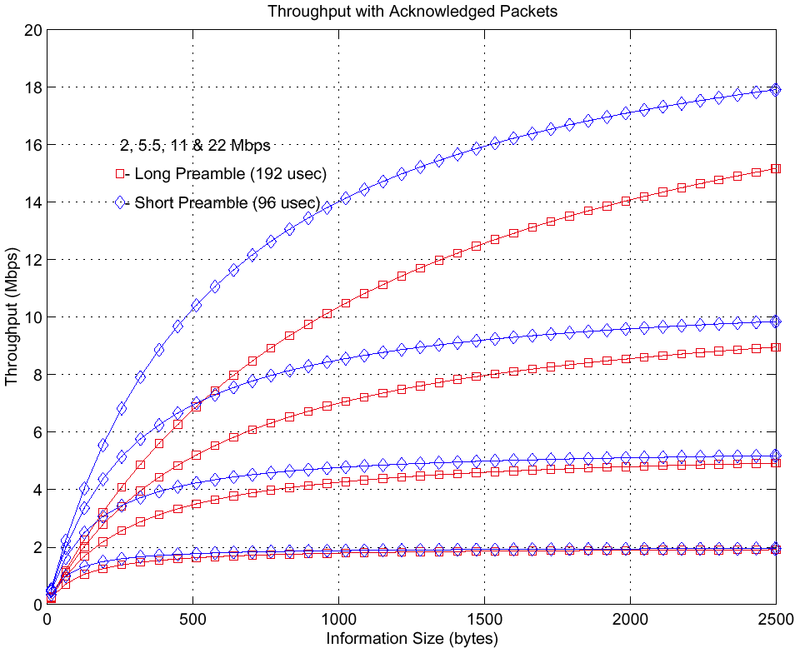
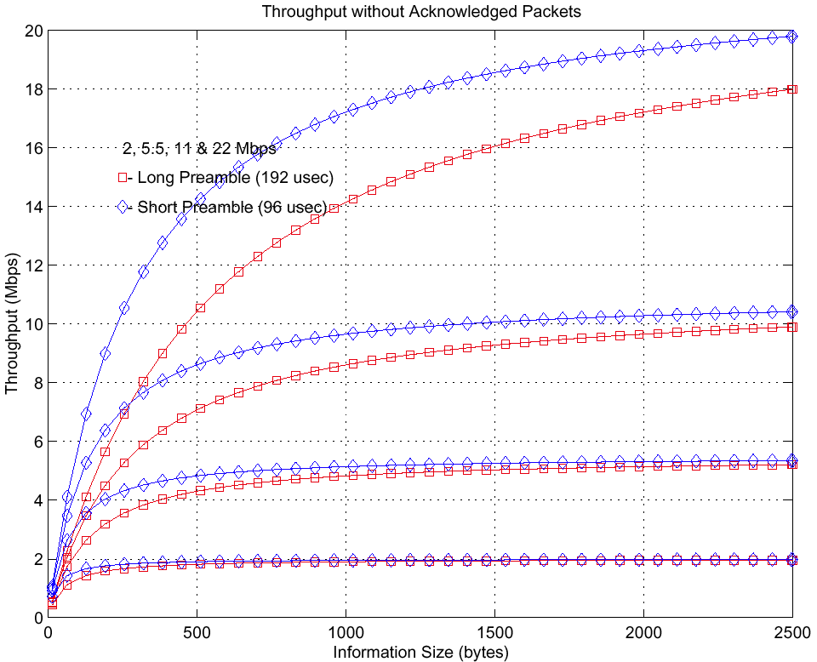

Packet size | Acknowledges? | Preamble | Throughput, Mbps
100 | Yes | Long | 1.8
100 | Yes | Short | 3.2
100 | No | Long | 3.8
100 | No | Short | 6.8
1000 | Yes | Long | 10.5
1000 | Yes | Short | 14.0
1000 | No | Long | 14.0
1000 | No | Short | 17.0
2346 | Yes | Long | 15.0
2346 | Yes | Short | 17.5
2346 | No | Long | 17.8
2346 | No | Short | 19.6

- Aggregate throughput in the 2.4GHz band (specify assumptions)
The aggregate throughput in the 2.4 GHz band, assuming three channels, each with a throughput of 22 Mbit/s, is 66 Mbit/s.
Non-AWGN Distortions

- PER versus Eb/No and Es/No (where Es is measured at the output of the transmitter) with 1000B packets simulated down to a PER of 0.01 or further.
  - With flat fading only
  - RMS delay spreads of 25, 100 and 250ns using model in document 282r2 with multipath and fading
  - RMS delay spreads of 25, 100, and 250ns using model in document 282r1 with no fading, i.e. normalized channels. Normalization should be done in simulation by scaling the signal at the output of the channel on a per packet basis, not by scaling the channel response. This is demonstrated on slide 12 of document 282r2.
For b and c the multipath channel sampling rate should be 4x the fundamental symbol rate of the transmitted waveform. The receiver may be run at a sampling rate other than 4x the fundamental symbol rate of the transmitted waveform, i.e. at 1x or 2x using a downsampling scheme. Provide assumptions used in simulations.
The sampling rate used was 4x the fundamental symbol rate of the transmitted waveform. No additional assumptions were made.
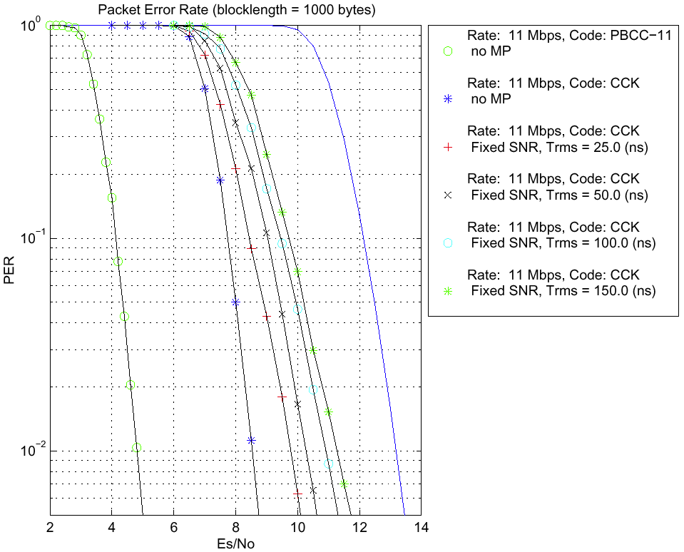

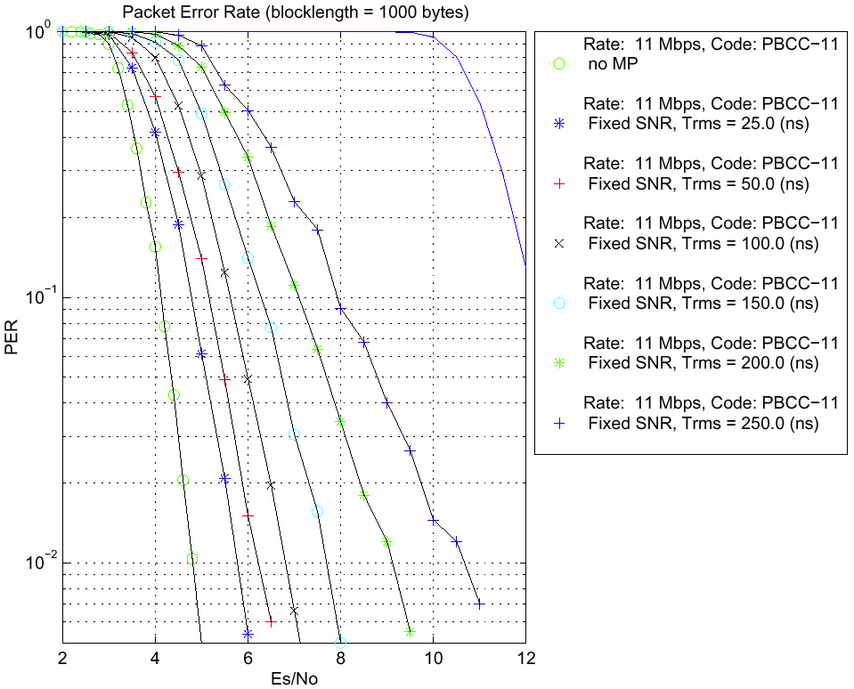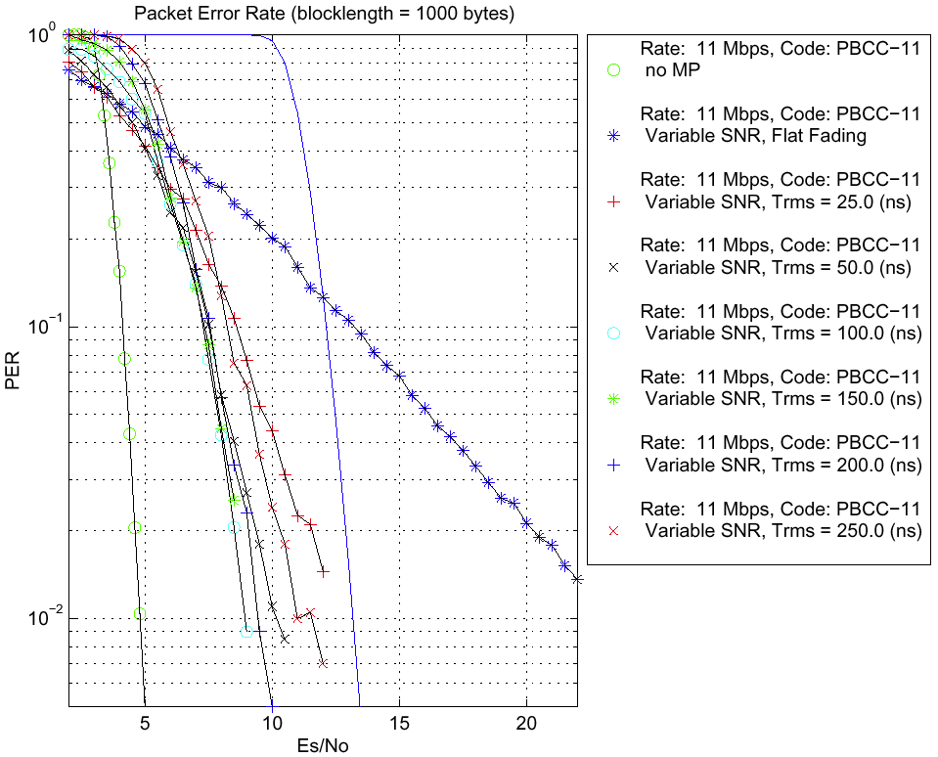
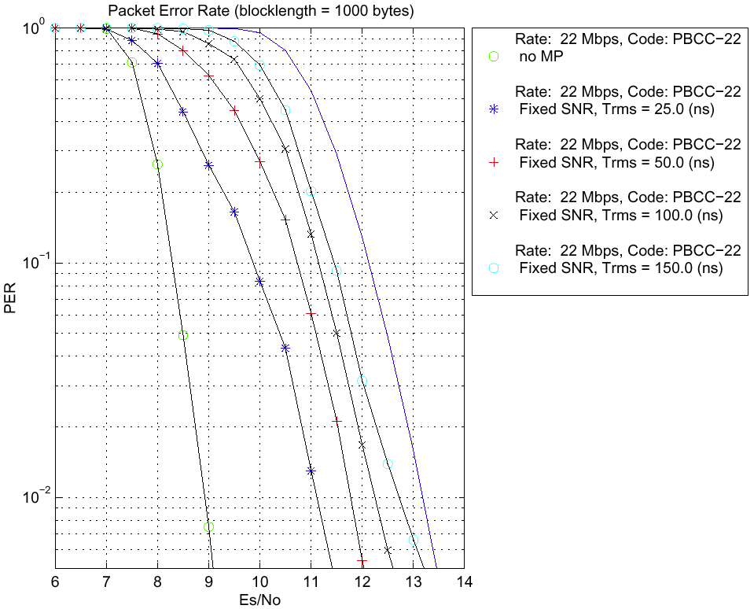
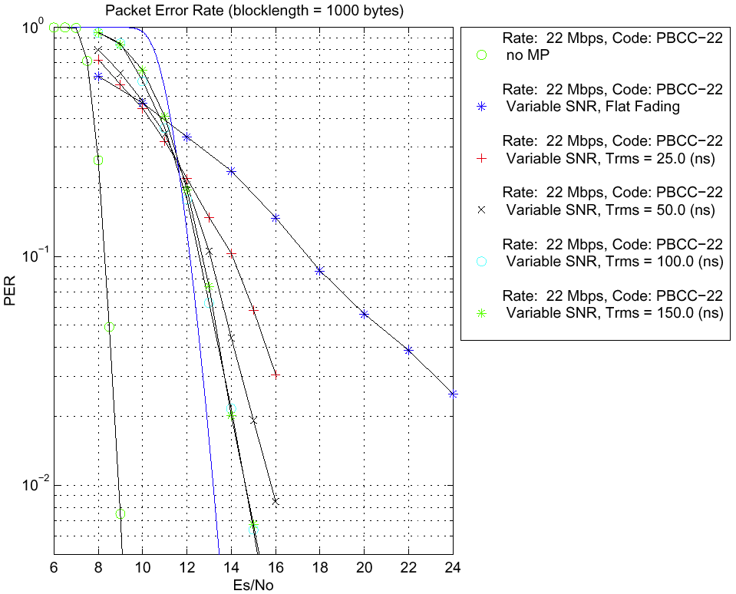
- For each modulation mode detemine and state the SNR (Es/No) at which in AWGN only, the waveform can achieve a PER of 0.01 for packets lengths of 1000B. Using the multipath model including fading (see item 23b above), fix the amount of AWGN at the 0.01 PER level for AWGN only. Increase the RMS delay spread until the PER for 1000B packets reaches 0.1. State the RMS delay spread at this point.

The 22 Mbps PBCC system achieves a PER of 0.01 at Es/No = 8.9 dB. This Es/No is low enough that with any fading, the system already cannot achieve a PER of 0.01, so that the answer to the question as stated is 0 ns. (See diagram in 23b.) Any system that has a strong code, and that therefore achieves a low Es/No for the target PER, will exhibit the same behavior.

- Performance using FCC jamming margin test. (Test specified in Section 15.247)
The following plot corresponds to using no adaptive equalizer.

The following plot is the result for PBCC-22 using an adaptive equalizer (lower curve) compared to using no adaptive equalizer (upper curve):

Non-ideal Receiver Effects

26. Carrier frequency offset and degradation at worst case carrier frequency offset.
For the 22 Mbps mode, only the modulation and coding schemes differ from the 802.11b 11 Mbps PBCC mode; a 256-state convolutional code with 8-PSK replaces a 64-state code with QPSK. Any algorithm used to track carrier frequency offset in 802.11b may also be used with the new mode.
There are two opposing effects on performance of any resulting residual carrier frequency offset. The larger signal set tends to make the system less robust than a system identical in every respect but with a QPSK signal set, in that the signal points are closer together. On the other hand, the stronger code means that the decoder is capable of tolerating greater degradation, as the coded sequences are further apart than in a system equivalent in every respect but with a 64-state code. This makes the system more robust. The net effect is that the system has low degradation, comparable to that of 802.11b systems.
- Baseband timing offset accuracy and degradation at worst case baseband timing offset
The remarks in response to item 26 above hold here also. The system exhibits low degradation, comparable to that of 802.11b systems, with the same timing offset tracking algorithms.
It is not necessary for the transmitter carrier clock and baud clock to be generated by the same source. This is convenient, as it has the effect of linking carrier frequency error and timing offset error, and hence rendering it easier to estimate the pair. It is proposed to make this a requirement for 11g-compliant systems, as in 802.11a, Sections 17.3.9.4 and 17.9.3.5
- Simulate sensitivity to phase noise using model in document 296r1. Use 3dB bandwidth of 20kHz. Sweep the RMS phase noise in degrees over a reasonable range. Show influence of carrier degradation in AWGN. Provide all assumptions, e.g. whether or not tracking loop is enabled or not. (Also reference doc. 98-156r3.)
For the following plot, no tracking loop was enabled.

Diversity
- How does the preamble allow for training of the receiver?

No new preambles are introduced in the proposal. All preambles behave as in an 802.11b system.

- Designed for receiver diversity?
Not applicable.
- If answer to previous question is YES, state antenna diversity and performance impact. (Prefer but do not mandate description of receiver structure(s).)
Not applicable.

Marketability
- Implementation complexity
Ease of customer integration has been a key driver in the entire design and development process for this particular high rate solution. It has been designed to maintain compatibility with today and tomorrow’s Wi-Fi™ solutions. It has also been designed to work seamlessly with existing 11 Mbps infrastructures. The 22 Mbps extension is fully interoperable with the IEEE 802.11b standard and has been shown to inter-operate with both Intersil and Lucent based products. For instances, a 22 Mbps enabled access point will recognize the capabilities of every IEEE 802.11b compliment client. Maintaining full conformity with the IEEE 802.11b specification, which satisfies existing certification requirements, will enable significant market growth, as no changes to existing regulations are necessary for users to immediately benefit from its availability. The proposed high-rate technology, which extends IEEE802.11b WLAN data rates from 11 Megabits per second (Mbps) to 22 Mbps, will enable a rich new set of wireless multimedia applications, including high-definition television (HDTV), interactive gaming and high-quality streaming video. With the anticipated wide-scale deployment of high-rate 802.11b technology in 2001, WLAN manufactures and their customers will enjoy immediate performance upgrades with the 2.4GHz spectrum.

- Maturity of solution and technology
In July, TI announced a 22 Mbps baseband processor for 802.11b that it is currently sampling to customers. Offering two times the performance over current 802.11b offerings, the sample chip is fully compatible with the IEEE 802.11b wireless LAN standard and intended for use in Wi-Fi applications. We are working with customers to fully productize the chip before the end of the year. Volume shipments will ramp in early 2001.
The technology is relatively mature as it embraces the current solution and uses advanced techniques to enhance the overall performance. The transmitted signal is spectrally the same as the other waveforms in the IEEE 802.11b standard. Thus, by not introducing any new spectral requirements to the existing IEEE 802.11b standard, this high-rate proposal allows for embracing existing technologies, while enhancing the performance. In addition, this has allowed for the 22 Mbps signal, via improved FEC, to be as robust as the 11 Mbps, CCK coded signal specified in the standard.

Early access partners have strongly embraced the performance that the processor achieves, in addition to its improved multipath performance over existing solutions. The solution clearly addresses customer careabouts by providing them higher rate, more robust devices at costs that are extremely competitive with existing and upcoming alternative 802.11b solutions.

- Power consumption estimate in TX, RX (decoding packet), IDLE (listening but no packet), and SLEEP (not listening) modes. Specify model and assumptions.

Power Consumption Table

 | Power Consumption Estimate
TX (decoding packet) | 40mW
RX (decoding packet) | 100mW
IDLE (listening, no packet) | 40mW
SLEEP (not listening) | .1mW

Model Use: IEEE 802.11 model
Assumptions: None

